Lab Assignment 5

# **Ques 1. WAP to swap the values of two numbers.**

echo "Write your first number"

read num1

echo "Write your second number"

read num2

temp=$num1

num1=$num2

num2=$temp

echo "Num1: $num1"

echo "Num2: $num2"

# **Output**

# 

# **Ques 2. WAP to perform addition, subtraction, multiplication, division and modulus of two numbers.**

echo "Enter the first number: "

read n1

echo "Enter the second number: "

read n2

s=`expr $n1 + $n2`

echo "Sum: $s"

sub=`expr $n2 - $n1`

echo "Subtraction: $sub"

p=`expr $n1 \* $n2`

echo "Product: $p"

d=`expr $n2 / $n1`

echo "Division: $d"

m=`expr $n1 % $n2`

echo "Modulus: $m"

# **Output**

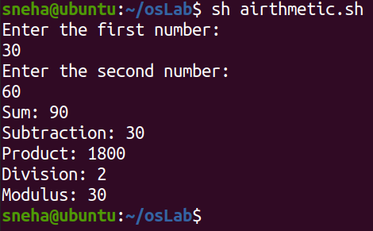

# **Ques 3. WAP to check whether a number is even or odd.**

echo "Enter your number"

read number

isEven=`expr $number % 2`

if [ $isEven -eq 0 ]

then

echo "Number is even "

else

echo "number is odd"

fi

# **Output**

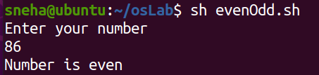

# **Ques 4. WAP to print the largest number among three numbers.**

echo "Enter the three numbers"

read a b c

if [ $a -gt $b -a $a -gt $c ]

then

echo "$a is  the gretest number"

elif [ $b -gt $a -a $b -gt $c ]

then

echo "$b is the gretest number"

else

echo "$c is the gretest number"

fi

# **Output**

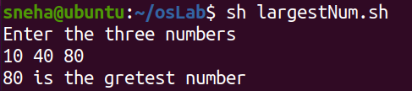

# **Ques 5. WAP to implement grading system.**

echo "Enter total marks of students"

read n

case $n in

100)

echo "O" ;;

9[0-9]) echo "O" ;;

8[0-9])echo "E" ;;

7[0-9]) echo "A" ;;

6[0-9]) echo "B" ;;

5[0-9]) echo "C" ;;

4[0-9]) echo "D" ;;

*)

echo "F";;

esac

# **Output**

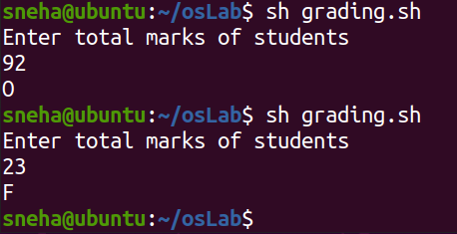

# **Ques 6. Write a shell program to find whether a given year is a leap year or not.**

echo "Enter Year: "

read yrs

x=`expr $yrs % 400`

y=`expr $yrs % 100`

z=`expr $yrs % 4`

if [ $x -eq 0 ] || [ $y -ne 0 ] && [ $z -eq 0 ]

then

echo "$yrs is a Leap Year"

else

echo "$yrs is not a Leap Year"

fi

# **Output**

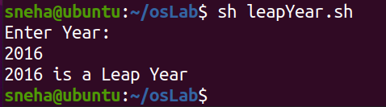

# **Ques 7. WAP to print numbers between 1 to 10.**

a=1

while [ $a -le 100 ]

do

echo $a

a=`expr $a + 1`

done

# **Output**

# **Ques 8. Write a shell script to display the gross salary of an employee (basic+da+hra).**

echo "Enter basic Salary"

read sal

da=`expr $sal \* 15 / 100`

hra=`expr $sal \* 30 / 100`

gross=`expr $sal + $da + $hra`

echo "Gross Income $gross"

# **Output**

# **Ques 9. Write a shell script to which will accept a number & find out the summation of square of last 3 digits.**

echo "Enter Number"

read num

count=0

sum=0

temp=$num

while [ $count -lt 3 ]

do

lastDigit=`expr $temp % 10`

sum=`expr $sum + $lastDigit \* $lastDigit`

temp=`expr $temp / 10`

count=`expr $count + 1`

done

echo "Sum of square of last 3 digit is $sum"

# **Output**

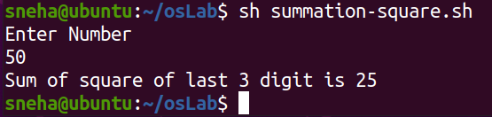

# 

# **Ques 10. Write a shell script to find out the electrical bill amount for consumer according to different unit charges.**

echo "-----------------------------------------"

echo 'Calculate Electricity Charge'

echo "-----------------------------------------"

echo "Enter the unit"

read unit

if [ $unit -gt 0 ] && [ $unit -le 50 ]

then

    charge=`expr $unit \* 50 / 100`

    echo $charge

elif [ $unit -gt 50 ] && [ $unit -le 150 ]

then

    charge=`expr 25 + $unit - 50 \* 75 / 100`

    echo "$charge"

elif [ $unit -gt 150 ] && [ $unit -le 250 ]

then

    charge=`expr 100 + $unit-150 \* 12 / 10`

echo "$charge"

elif [ $unit -gt 250 ]

then

    charge=`expr 100 + $unit-150 \* 120 / 100`

echo "$charge"

fi

sur_charge=`expr $charge \* 2 / 10`

total_amt=`expr $charge + $sur_charge`

echo -----------------------------------------

echo "Electricity Billing"

echo -----------------------------------------

echo "Unit:$unit"

echo "charge:$total_amt"

echo -----------------------------------------

# **Output**

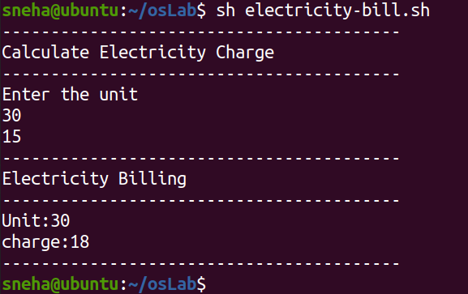

# **Ques 11. Write a shell script to calculate the overtime (Hours) payment of an employee as per rules.**

echo "Enter Hours"

read hrs

overtime=`expr $hrs - 8`

pay=15

if [ $overtime -gt 0 ]

then

amt=`expr $overtime \* $pay`

echo "Overtime: $amt"

else

echo "No Overtime"

fi

# **Output**

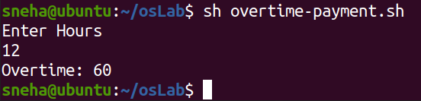

# **Ques 12. Write a shell program to evaluate the operation 12+22+32+......+n2**

echo "Enter the value of n"

read n

firstTerm=`expr $n + 1`

secondTerm=`expr $n \* 2 + 1`

result=`expr $n \* $firstTerm \* $secondTerm / 6`

echo "Your result is $result"

# **Output**

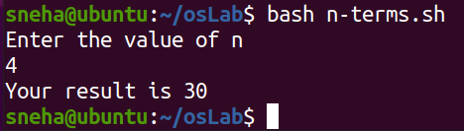

# **Ques 13. Write a shell script to display the alternate digits in a given seven digits number starting first digit.**

echo "Enter your number"

read num

lastDigit=0

while [ $num -gt 0 ]

do

lastDigit=`expr $num % 10`

echo "$lastDigit"

num=`expr $num / 100`

done

# **Output**

# **Ques 14. Write a shell script to print all the even odd between 0 to 100.**

echo "Odd Numbers Between 0-100"

for(( i=1 ; i<=100 ; i=i+2))

do

 echo "$i"

done

echo "Even Numbers Between 0-100"

for(( i=0 ; i<=100 ; i=i+2))

do

 echo "$i"

done

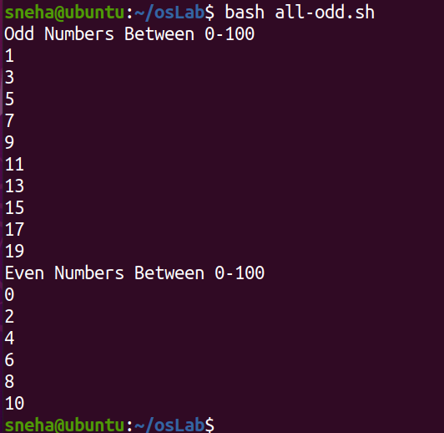

# **Output**

# **Ques 15. Write a shell script to print factorial of a given number.**

echo "Enter a Number: "

read num

fact=1

while [ $num -gt 1 ]

do

  fact=`expr $fact \* $num`

  num=`expr $num - 1`

done

echo $fact

# **Output**

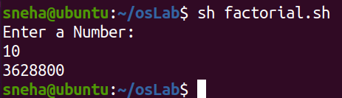

# **Ques 16. Write a shell script to print Fibonacci series starting from 0.**

echo "Enter number of terms: "

read n

nextTerm=1

term=0

echo "$term"

echo "$nextTerm"

while [ $n -gt 0 ]

do

sum=`expr $term + $nextTerm`

echo "$sum"

term=`expr $nextTerm`

nextTerm=`expr $sum`

n=`expr $n - 1`

done

# **Output**

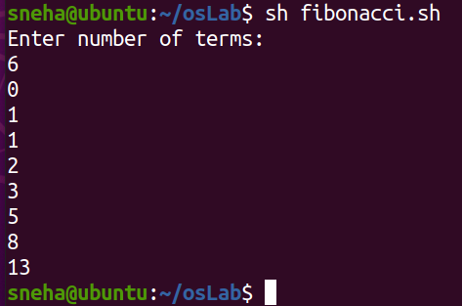

# **Ques 17. Write a shell script to print a number in reverse order & calculate its sum of its digits.**

echo "Write a number"

read num

temp=$num

rev=0

sum=0

while [ $temp -gt 0 ]

do

lastDigit=`expr $temp % 10`

rev=`expr $rev \* 10 + $lastDigit`

sum=`expr $sum + $lastDigit`

temp=`expr $temp / 10`

done

echo "Reverse number is $rev"

echo "Sum of Digits is $sum"

# **Output**

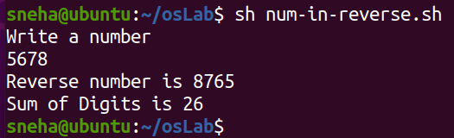

# **Ques 18. Write a shell script to find (check whether) palindrome numbers in a given range.**

echo "Enter a Number : "

read a

sum=0

num=$a

while [ $num -gt 0 ]

do

d=`expr $num % 10`

sum=`expr $sum \* 10 + $d`

num=`expr $num / 10`

done

if [ $sum -eq $a ]

then

echo "Palindrome Number"

else

echo "Not a Palindrome Number"

fi

# **Output**

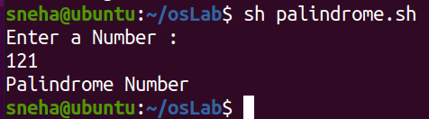

# **Ques 19. Write a shell script to print the prime numbers in a given range.**

echo "Enter the range num1 and num2:"

read num1 num2

echo "Given range from user is $num1 anf $num2 "

echo "Prime Numbers are:"

while [ $num1 -le $num2 ]

do

i=2; flag=1

while [ $i -lt $num1 ]

    do

        if [ `expr $num1 % $i` -eq 0 ]

        then

            flag=0

            break

        else

            i=`expr $i + 1`

        fi

    done

    if [ $flag -eq 1 ]

    then

        echo $num1

    fi

    num1=`expr $num1 + 1`

done

# **Output**

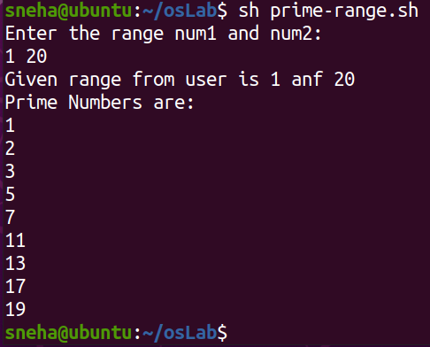

# 

# **Ques 20. Write a shell script to find (check whether) Armstrong numbers in a given range.**

echo "Enter the number"

read number

revNumber=0

loopCounter=$number

while [ $loopCounter -gt 0 ]

do

lastDigit=`expr $loopCounter % 10`

revNumber=`expr $revNumber + $lastDigit \* $lastDigit \* $lastDigit`

loopCounter=`expr $loopCounter / 10`

done

if [ $number -eq $revNumber ]

then

echo "Your number is Armstrong Number"

else

echo "Your number is not Armstrong Number"

fi

# **Output**

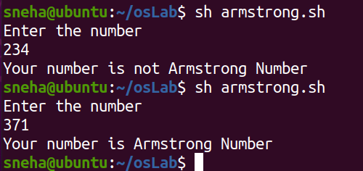

# **Ques 21. Write a shell script to convert decimal number to binary number.**

echo "Enter the num"

read n

val=0

power=1

while [ $n  -ne 0 ]

       do

        r=`expr $n % 2`

        val=`expr $r \* $power + $val`

        power=`expr $power \* 10`

        n=`expr $n / 2`

      done

echo "Binary equivalent=$val"

# **Output**

# 